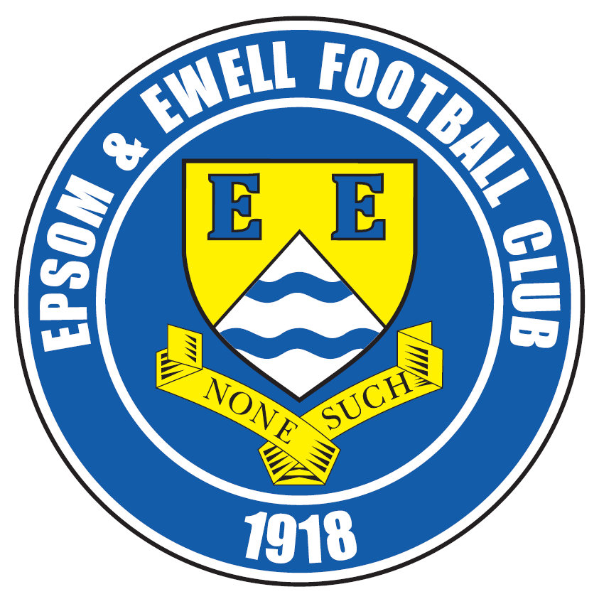 | Epsom & Ewell F.C.  25  v  Windsor F.C.  Tuesday, 21st March 2017 – 7.45 p.m.
Good evening! We welcome the players, supporters and officials of Windsor Football Club, today’s officials and our own regular faces for this important League Cup Semi-Final match.

This is our first major Semi-Final at home since 1989 when Carshalton Athletic were the visitors for a 2-2 draw in the Surrey Senior Cup. Many of you will of course remember our League Cup win in 2013 when we won 1-0 over at Champions Egham Town in the Semi-Final and before that another Surrey Senior Cup Semi-Final at Ashford Town (Mx) in 2009. Apart from that, the cupboard has been fairly bare since an Associate Members Trophy win at Wealdstone in 1998.

We expect a difficult challenge tonight from our opponents as we mark the fiftieth meeting between the clubs. We both won our home matches against each other in the League and although we hold a slight advantage if you look at the League table, this counts for little as Raynes Park Vale proved when knocking Hartley Wintney out in an earlier round.

In fact it is many years since there was a League and Cup double. You have to go back to 2008 when the all-conquering Merstham team were Champions and they defeated Bedfont Green 4-2 after extra time. Also, who would have expected Farnham Town to win it last year, defeating overwhelming favourites Camberley Town at Stag Meadow.

We have no details yet of any Cup Final. I assume this is because the intention is to play the match once again at Windsor, unless they were to reach the Final tonight, in which case it would surely be played elsewhere. I think I am fairly safe in saying that if we were to win tonight, we would be playing the Cup Final at Windsor, almost certainly on Saturday 29th April, but this is purely a guess at this point. The other Semi-Final will also be played tonight as Raynes Park Vale host Westfield.

We hosted Hartley Wintney on Saturday and lost 0-1 in an extremely close match. On another day we would have definitely claimed a draw and I am informed that we actually had more chances than they did, but there have been other matches we have pinched and it evens up over the season. It must be said though that we have conceded first in our last four matches and need to stop that happening as some teams are capable of locking the door as we found against Hartley.

We welcome Farnham Town next Saturday in another important League match as we continue our quest for a top four position. We then have away matches at Camberley Town and Knaphill before hosting Colliers Wood United on Good Friday in a match that will take place at 1.00pm.

Enjoy the game!

Rich

You can follow us on Facebook: www.facebook.com/epsomandewellfc
Twitter: @EEFCOfficial Instagram at: www.instagram.com/epsomandewellfc
and on Youtube at: www.youtube.com/channel/UCtLrpS0x5OaYUACRT34_zng

Today’s Cover Photos

- Rob Hendry sends a glancing header into the net at home to Bedfont & Feltham

- Matt Farrell scores our fourth goal in the same match


Cherry Red Records Combined Counties League
Premier Division Table 2016/17
inc Saturday 18th March | P | W | D | L | F | A | Pts | GD | H | A
Hartley Wintney | 36 | 30 | 4 | 2 | 122 | 35 | 97 | +87 | 0-1 | 1-3
Westfield | 36 | 22 | 8 | 6 | 81 | 42 | 74 | +36 | 2-1 | 1-2
Hanworth Villa | 38 | 22 | 8 | 8 | 68 | 39 | 74 | +25 | 2-2 | 0-1
Walton & Hersham | 38 | 20 | 13 | 5 | 66 | 37 | 73 | +26 | 1-1 | 1-1
Epsom & Ewell | 38 | 20 | 9 | 9 | 81 | 48 | 69 | +33 | X | X
Camberley Town | 36 | 17 | 6 | 13 | 71 | 52 | 57 | +19 | 0-0 | 1/4
Horley Town | 37 | 17 | 6 | 14 | 78 | 61 | 57 | +17 | 3-0 | 17/4
Abbey Rangers | 38 | 15 | 10 | 13 | 62 | 63 | 55 | -1 | 7-1 | 1-0
Spelthorne Sports | 38 | 14 | 9 | 15 | 68 | 67 | 51 | +1 | 3-2 | 2-2
Knaphill | 35 | 15 | 4 | 16 | 65 | 69 | 49 | -4 | 4-0 | 8/4
Bedfont Sports | 34 | 14 | 7 | 13 | 59 | 64 | 49 | -5 | 5-1 | 3-1
Windsor | 36 | 13 | 9 | 14 | 65 | 59 | 48 | +6 | 2-0 | 1-2
North Greenford United | 33 | 14 | 5 | 14 | 65 | 61 | 47 | +4 | 22/4 | 1-2
Sutton Common Rovers | 34 | 14 | 4 | 16 | 49 | 52 | 46 | -3 | 2-1 | 1-1
Guildford City | 38 | 13 | 6 | 19 | 70 | 78 | 45 | -8 | 1-0 | 2-0
Farnham Town | 38 | 13 | 6 | 19 | 56 | 74 | 45 | -18 | 25/3 | 2-1
AFC Hayes | 38 | 11 | 9 | 18 | 58 | 72 | 42 | -14 | 2-2 | 0-1
Chertsey Town | 36 | 12 | 6 | 18 | 50 | 82 | 42 | -32 | 2-1 | 3-0
CB Hounslow United | 36 | 12 | 4 | 20 | 50 | 71 | 40 | -21 | 1-5 | 2-0
Colliers Wood United | 36 | 10 | 9 | 17 | 56 | 68 | 39 | -12 | 14/4 | 0-5
Badshot Lea | 37 | 9 | 4 | 24 | 53 | 100 | 31 | -47 | 4-2 | 4-1
Raynes Park Vale | 37 | 6 | 8 | 23 | 40 | 78 | 26 | -38 | 1-1 | 1-1
Bedfont & Feltham | 36 | 6 | 6 | 24 | 46 | 107 | 24 | -61 | 4-1 | 9-2

Lucky Day? – 21st March
Played 17 - Won 5 Drawn 3 Lost 9 - For 20 Against 30 - PPG 1.06 - Poor
Our Club record against today’s opponent (including Windsor & Eton)
Played 49 - Won 19 Drawn 12 Lost 18 - For 90 Against 90 - PPG 1.41 - Average
Our Largest wins and losses against today’s opponent
11th February 1984 - W 4-0 - Isthmian League Division One (H)
29th March 2003 - W 4-0 - Isthmian League Division One South (H)
15th August 1970 - L 0-6 - Athenian League Division Two (A)
Their Last Visit
15th November 2016 - Won 2-0 - Combined Counties League

First Eleven Appearances 2016/17 - (max 48)
Name | Debut | 2016/17 |  |  |  | Career Totals
Name | Debut | App | Sub | Total | Goals | App | Sub | Total | Goals
CLARK-GLEAVE Charlie* | 23/08/2016 | 3 | 2 | 5 | 0 | 3 | 2 | 5 | 0
COOPER-SMITH Daryl | 03/01/2015 | 30 | 5 | 35 | 31 | 60 | 13 | 73 | 51
DEAN Dan | 02/08/2014 | 35 | 2 | 37 | 2 | 103 | 6 | 109 | 4
DEWAR Ali | 29/10/2011 | 0 | 5 | 5 | 0 | 55 | 40 | 95 | 10
EACOTT Michael | 02/08/2014 | 40 | 0 | 40 | 0 | 125 | 1 | 126 | 0
FARRELL Matt | 02/08/2014 | 44 | 0 | 44 | 16 | 130 | 4 | 134 | 34
FERDINANDO Matt | 20/09/2014 | 27 | 8 | 35 | 9 | 80 | 14 | 94 | 23
GALLAGHER Jordan | 07/08/2016 | 34 | 12 | 46 | 11 | 34 | 12 | 46 | 11
GRIFFIN Reisse | 08/08/2015 | 38 | 6 | 44 | 2 | 66 | 12 | 78 | 4
HASTINGS Craig | 08/08/2015 | 29 | 7 | 36 | 2 | 66 | 11 | 77 | 2
HEAGNEY Adam | 16/08/2016 | 33 | 7 | 40 | 0 | 33 | 7 | 40 | 0
HENDRY Rob | 08/08/2015 | 33 | 9 | 42 | 10 | 63 | 20 | 83 | 22
MCKAY Alex | 20/12/2008 | 18 | 6 | 24 | 3 | 126 | 36 | 162 | 11
NEALE Tom* | 13/10/2015 | 6 | 5 | 11 | 7 | 22 | 24 | 46 | 17
NORTH Rhys | 16/08/2015 | 3 | 3 | 6 | 0 | 20 | 10 | 30 | 1
NWACHUKWU Jason | 01/10/2016 | 13 | 12 | 25 | 1 | 13 | 12 | 25 | 1
PANAYIOTOU Savvas | 03/01/2015 | 40 | 4 | 44 | 5 | 72 | 12 | 84 | 12
PRICE Matt* | 23/08/2016 | 2 | 0 | 2 | 1 | 2 | 0 | 2 | 1
ROBINSON Sam* | 22/10/2011 | 7 | 1 | 8 | 1 | 61 | 6 | 67 | 14
ROSE Daniel | 25/10/2016 | 2 | 5 | 7 | 0 | 2 | 5 | 7 | 0
SALEH Mennar* | 24/09/2016 | 0 | 2 | 2 | 0 | 0 | 2 | 2 | 0
SMITH Matt | 08/08/2009 | 0 | 3 | 3 | 1 | 91 | 46 | 137 | 11
TANTON Matt | 02/08/2014 | 39 | 2 | 41 | 1 | 96 | 6 | 102 | 3
TAYLOR James | 26/08/2013 | 40 | 3 | 43 | 2 | 126 | 15 | 141 | 8
THOMPSON Elliott | 09/02/2016 | 3 | 0 | 3 | 1 | 7 | 9 | 16 | 1
TURPIE Alistair | 31/03/2016 | 8 | 1 | 9 | 0 | 10 | 1 | 11 | 0
WATRET Jack* | 02/08/2016 | 1 | 0 | 1 | 0 | 1 | 0 | 1 | 0
Own goals |  |  |  |  | 1
* player has left the club

EL Records Premier Challenge Cup
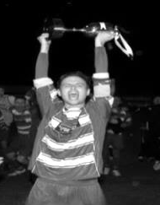
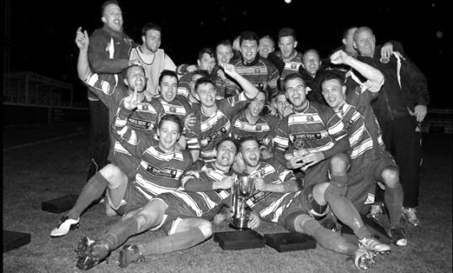
Second Round
Hanworth Villa | 2-4+ | Epsom and Ewell
AFC Hayes | 3-4 | Balham
Epsom Athletic | 1-5 | Windsor
Sutton Common Rovers | 2-1 | Bedfont Sports
Raynes Park Vale | 2-0 | Colliers Wood United
Frimley Green | 1-2 | Banstead Athletic
Westfield | 8-4+ | Redhill
Staines Lammas | 0-1 | Farnham Town
Worcester Park | 8-1 | Cove
Badshot Lea | 0-5 | Guildford City
Chertsey Town | 1-2 | Camberley Town
Cobham | 1-3 | Chessington & Hook United
Hartley Wintney | 4-0 | AC London
Horley Town | 2-2+ 5-4p | Sheerwater
Walton & Hersham | 5-1 | Eversley & California
Ash United | 2-0 | Farleigh Rovers
Third Round
Banstead Athletic | 4-4+ 3-4p | Westfield
Sutton Common Rovers | 1-3 | Walton & Hersham
Farnham Town | 0-4 | Camberley Town
Ash United | 0-2 | Windsor
Raynes Park Vale | 2-1 | Hartley Wintney
Guildford City | 2-1 | Balham
Horley Town | 2-0 | Chessington & Hook United
Worcester Park | 3-6 | Epsom & Ewell
Quarter Finals
Windsor | 2-0 | Horley Town
Guildford City | 1-2 | Raynes Park Vale
Westfield | 4-1 | Camberley Town
Walton & Hersham | 1-3 | Epsom & Ewell
Semi Finals
Epsom & Ewell | 21/3 | Windsor
Raynes Park Vale | 21/3 | Westfield

Latest Results and Fixtures
Combined Counties League – Saturday 18th March
Bedfont & Feltham | 3-2 | Colliers Wood United
Camberley Town | 1-3 | AFC Hayes
Chertsey Town | 2-1 | Raynes Park Vale
Epsom & Ewell | 0-1 | Hartley Wintney
Farnham Town | 2-1 | Knaphill
Hanworth Villa | 4-0 | Badshot Lea
Horley Town | 2-0 | CB Hounslow United
North Greenford United | 2-1 | Guildford City
Spelthorne Sports | 1-1 | Abbey Rangers
Sutton Common Rovers | 0-1 | Walton & Hersham
Westfield | 2-1 | Windsor
Combined Counties League – Monday 20th March
Abbey Rangers | V | North Greenford United
Sutton Common Rovers | V | Bedfont & Feltham
Combined Counties League Cup Semi-Finals – Tuesday 21st March
Epsom & Ewell | V | Windsor
Raynes Park Vale | V | Westfield
Combined Counties League – Tuesday 21st March
Badshot Lea | V | Chertsey Town
Knaphill | V | Horley Town
Combined Counties League – Saturday 25th March
Badshot Lea | V | Sutton Common Rovers
Bedfont Sports | V | Spelthorne Sports
CB Hounslow United | V | Abbey Rangers
Chertsey Town | V | Colliers Wood United
Epsom & Ewell | V | Farnham Town
Guildford City | V | Walton & Hersham
Hartley Wintney | V | Horley Town
Knaphill | V | North Greenford United
Raynes Park Vale | V | Camberley Town
Westfield | V | Bedfont & Feltham
Windsor | V | AFC Hayes

From behind the goal
Epsom & Ewell 0-1 Hartley Wintney
Combined Counties League - Premier Division - Saturday 18th March 2017

Salts just fall short in acid test

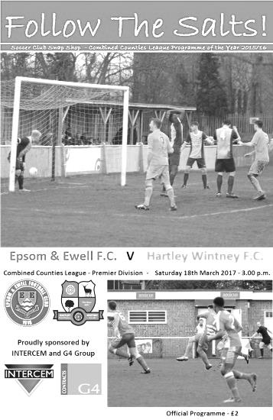
Our seventeen match unbeaten home league run ended on Saturday at the hands of Champions elect Hartley Wintney. In fact, had Westfield not scored a late winning goal the same day, the Row, as they are known, would have been celebrating a title win before reaching the end of March; an achievement not seen since Merstham won the League and Cup double in 2008.

We have played four times over the last two seasons, drawing once and narrowly losing three of the matches but it has to be said that over that time we have stood up well to a very good team and probably deserved more for our efforts. On the day once again we were well worthy of a point, but missing our suspended leading goal scorer Daryl Cooper-Smith we failed to give the visiting defence, marshalled once again by the superb Liam Eagle, more of a test and in a match of few chances for either side we didn't hit the target often enough, only forcing visiting keeper Jack Maddock into one real save midway through the second half.

At the other end we dealt well with the Hartley threat, whose goal scoring threat was restricted to sporadic chances and the goal that separated the two teams came from a clever piece of skill by their leading scorer Sam Argent, showing quick feet to turn and fire in after we failed to deal with a long throw. For Epsom supporters not at the game it reminded me of the quick feet of one of our recent strikers, Robbie Burns, who used to score similar goals.

We made just one change from the win at Bedfont Sports as Captain Dan Dean returned to the line up at the expense of Craig Hastings and the opening exchanges were even with both teams creating an opportunity but on each occasion their crosses were intercepted by Michael Eacott and then Maddock. Rob Hendry turned well to get round Eagle but his low left wing cross was cleared for a corner. The visitors’ main threat appeared to come from long throws at this stage that we seemed to be dealing well enough with and we nearly broke through in the 24th minute when an Agi Panayiotou free kick was bravely headed away by Dean Stow just ahead of the incoming Matt Ferdinando.

We caused panic in the 27th minute as a ball into the Hartley danger area was only half cleared and was falling to Hendry but just as he went towards the ball he slipped and this just gave the visitors time to get there first, but again the ball wasn't cleared and in the ensuing mêlée Hendry was nudged over from behind and then Jordan Gallagher set up Ferdinando for a volley from 10 yards but on his weaker left side he couldn't keep the ball down. Some people thought that Hendry should have had a penalty but it was already clear

by this stage that the referee was going to make every attempt to keep play going in this match, and there just wasn't enough there in my opinion.

Reisse Griffin was next to try his luck as the ball came to him 25 yards out and he was unfortunate to see the ball just bend away from the top corner, only missing the post by about a foot with Maddock beaten. We then had a scare of our own when a deep cross from the right was met at the back post by a volley from Eagle which hit one of our defenders and flew to safety. Back at the other end, Gallagher went outside of his man but on his weaker left foot he sliced the attempted cross. This cost us almost immediately as the visitors led in the 39th minute. A long throw was not headed away and the ball fell to the feet of Argent with his back to goal but a quick turn and shot and they were ahead.

The lead was nearly doubled just after the restart as a right wing cross was controlled and then struck across goal but Eacott made a good low save at full stretch and the loose ball was cleared. The game continued in the same manner as the first half with both teams largely cancelling each other out but creating the occasional half chance. A great cross by Adam Heagney was just headed away for a corner at the far post while the visitors headed just wide from another long throw. We had a good opportunity when earning a free kick on the edge of the box but Ferdinando's shot was comfortably saved by Maddock.

Dean headed a corner over the bar on the hour mark but we created another chance soon after. It started with a long ball that Hendry appeared to be on to but Maddock was out to clear quickly. Unfortunately for him it went straight to Ferdinando but 25 yards out and with a wide open goal his touch let him down and he couldn't get the shot in. He did find Griffin on the right wing though and his deep cross found Gallagher whose low shot on target was well saved by Maddock with the ball bouncing up just too far for the incoming Heagney to keep his volley down from 12 yards out.

It was beginning to look like one of those days and another ball over their defence required Maddock to leave his area again to head clear but the ball fell to Hendry whose lob from 20 yards was wide of the vacated goal. Two minutes later a Gallagher free kick was headed back across goal by Dean at the far post but Farrell tried to lift his header over the nearby defenders and got too much on it, sending it over the bar. There was a final opportunity for Hendry as time ran out but it was a difficult one and he couldn't get his glancing header on target.

Ultimately this match followed a very similar pattern to last year in that the visitors scored in the first half of a match that was low on chances and held on for the 1-0 win. In my opinion we were worth a point again but Hartley showed that even on a day where they are well matched by the opposition and not allowed to play their flowing football, they are still able to grind out results. That's why they are well clear at the top and in view of their impending promotion to a different area of the pyramid this was probably the last meeting between the teams, for a while anyway. For our part, we will lick our wounds and prepare for Tuesday's big League Cup Semi-Final in the knowledge that we matched the league's best team for 90 minutes and against any other opposition in the league would probably have won.

Epsom and Ewell: Michael Eacott, Adam Heagney, Matt Tanton, James Taylor, Dan Dean (c), Savvas 'Agi' Panayiotou, Jordan Gallagher, Matt Farrell, Rob Hendry, Matt Ferdinando,
Reisse Griffin

Sub: Jason Nwachukwu for Griffin (74)

Windsor F.C. – History

Summer 2011 and it’s rather ironic that 100 years of senior football at Stag Meadow should be celebrated by the birth of a brand new club, Windsor FC, which came to be following the sad demise after 118 years of Windsor & Eton FC. During the final death throes of the previous club it became apparent, following several well attended supporters’ meetings, that the will was there to continue to host a senior football club in Windsor for the community to embrace and, therefore, on February 4th 2011 WFC Football Community Development Ltd was registered with Companies House with the aim of achieving that objective. Founding Director Kevin Stott and a newly-appointed management committee then set about the long and sometimes arduous task of turning that dream into a reality.

A business plan centred around self-sustainability was formulated and presented to the Football Association which eventually led to acceptance for the new club at level 5 of the non-league system and an allocation to compete in the Premier Division of the Cherry Red Records Combined Counties League for season 2011/12. Now the new club had been accepted it needed a name and invitations were extended to the people of Windsor to nominate and then vote on the new naming process and thus Windsor FC was born.

Self-sustaining and community are the two key elements behind the ethos of the new setup and the provision of a 3rd generation artificial surface training area/small-sided games pitches at the Great Park end of the ground, when completed, will form the foundations of the self-sustainability module as well as providing a much-needed facility for the community to use. The other main development thus far on the community side is welcoming on board the 34 teams and over 300 players of New Windsor Youth FC who will now be known as Windsor FC Youth, adopting the club badge and colours and providing a progression pathway from small-sided through to senior football for the youth of the town of Windsor.

One of our other innovative community involvement schemes sees our club mascot ‘Scotty the Stag’ regularly appearing at local school fetes and other events around the town publicising the club as well as supporting the fund raising activities of the club in general. In his spare time Scotty is becoming a bit of a celebrity taking part in races such as the Mascot Grand National and despite some close finishes is yet to claim his first win but if medals were given for effort then Scotty would be No.1 on the podium just for the amount of money he has raised for various local charities!

Our founding season turned out to be a very exciting one, eventually finishing as runners-up to worthy Champions Guildford City in the League. Several weeks into season 2012/13 a major decision to operate without a budget was taken to free up funds for the regeneration plans at the ground and the management team and all but three of the playing squad left immediately. Mick Woodham was appointed as our new manager and had two days to get together a squad before our next league game. Despite some heavy defeats early in his tenure as he built a squad of local youngsters the club never lost faith and Mick eventually put together a squad that was to finish a very creditable 6th in the league.

Recognition from the league away from football itself was achieved with a runners-up award for the programme in the Premier Division and FA Groundsman of the Year award for the CCL and this was added to in August 2013 when our groundsman Lewis Clements won the FA Groundsman of the Year Award for the whole of Step 5 and 6 football nationally. This building process continued for season 2013/2014 as players were added to the squad with the emphasis on young local players interspersed with some older experienced heads but whatever happened results wise we continue to enjoy visiting the many friends we made in our first two seasons in the Combined Counties League and hope they all enjoy their visits to Stag Meadow. A sixth place was recorded in the Combined Counties League, with early exits in the FA Cup and the FA Vase. The highlight of the season was a 3-0 win over Reading Town in the Berks & Bucks Senior Trophy.

In 2014-2015 we again finished a creditable 5th in the Combined Counties League but again suffered early exits in both the FA Cup and FA Vase. Success did come again in the Berks & Bucks Senior Trophy when we retained the title with a 3-2 extra time win over neighbours Flackwell Heath.

In 2015-2016 we had a number of changes on the player front and ended up halfway in 12th place in the Combined Counties League. The FA Cup saw us go out at the first time of asking while in the FA Vase we went through 3 rounds before losing to our league champions Hartley Wintney in Round Two. Our defence of the Berks & Bucks Senior Trophy ended on a very cold icy night when we lost to Newport Pagnell Town in the Quarter Final.

In 2016-2017 we will play in the Cherry Red Records Combined Counties League Premier Division and will have two under 18 teams in the Allied Counties Youth League plus many sides competing in local youth leagues for Windsor FC Youth.

Windsor F.C. – Player Profiles

MANAGEMENT

MICHAEL WOODHAM (MANAGER) Was appointed in September 2012, previously being our u18's Manager in season 2011/2012. Prior to that Mick was the u18s Manager at Burnham. Mick has also held 1st team coaching positions at both Bracknell Town and Beaconsfield SYCOB before taking up his current post. His playing career saw him play for Windsor & Eton FC Reserves for a number of years as well as being a valued member of the all-conquering Carpenters Arms team in Sunday football! Has won two trophies in four years at the club.

ASHLEY SMITH (PLAYER COACH) joined the club in the summer of 2016 having previously played at Chesham United, Burnham, Maidenhead United, Flackwell Heath and Hampton & Richmond Borough. Now a fulltime coach he has taken his first steps into management and will be an asset both on and off of the pitch.

GOALKEEPERS

HUGO SOBTE made his first team debut a winning one in our home win against Badshot Lea in 2015. Hugo has also played as a striker for our u18s! A real product of Windsor.

HENRY POOLE made his debut in October 2016. Came through our youth team and first showed his quality in pre season. Another real product of Windsor.

DEFENDERS

DEAN ALDRED Signed prior to the 2016-2017 season from Amersham Town. An experienced left footed defender with an eye for a pass.

RICCARDO CANNON Striker/Defender signed from local football in August 2015 having played for many of the local clubs including Burnham and Flackwell Heath. Tall and agile who is comfortable down the middle or out wide and does a pretty good job in defence.

HAYDON CLACK Recent signing from Burnham FC. Commanding fullback who is not afraid to get forward to help those up front. Ex Academy guy under Ashley Smith.

JAMIE DI GIUSEPPE Not sure how he's not been picked up by a local senior club before now but came to our attention playing Sunday football for Langley Wanderers. Great crosser and pass-picker and has a good scoring record from dead-ball situations. Recently returned to the club after a spell at Chalfont St Peter.

EMMANOYUIL GOGANOS Known as Mano and recently moved to Windsor from his native Greece. An energetic and reliable defender, able to play either full-back.

MIDFIELDERS

BRADLEY BIRCHMORE a product of our youth team. Recently made his debut as a substitute. A very bright prospect for the future.

DENZEL BONILLA-HURTADO another product of the Cox Green Academy. Exciting prospect. Has had senior experience at Southall FC and was with Aylesbury United.

LUKE BROOKS-SMITH made his debut in October 2015. Has been made club captain this season. A steadying influence in the middle of the pitch. Former Chalfont St Peter player who also appeared for Hillingdon Borough. Currently working for Brentford FC as a Sports Coach.

GEORGE GOULD popular midfield who recently returned after a spell at Hanworth Villa.

ELLIS JONES-ARYEH battling strong midfielder who recently signed for the club from Bedfont & Feltham. Quickly become an influential member of the team.

BRADLEY PEARCE Another youngster studying at the Cox Green Academy. Tall and elegant defender who is looking to force his way into the First Team squad on a regular basis.

NADIR SHAFI another product of the Cox Green Academy. Nadir has recently found himself regularly in the squad

TAUFEE SKANDARI yet another product from the Cox Green Academy, recent addition to the squad where hopes are high.

FORWARDS

GUS BOWLES the Under 18s centre forward who earned the opportunity to join the first team squad with some outstanding performances. Made his debut as a substitute in October 2016.

BARRY DUNBAR Striker signed August 2014 from local football. A hard working honest centre forward who finds himself in the right place at the right time. Has hit double figures in both seasons with the club and has become a cult-hero, nicknamed Super Barry.

ANDREW INGRAM yet another of our Cox Green Academy contingent. Prolific goal scorer at youth level. Tall centre forward, excellent in the air. An old-fashioned target man who is looking to develop with and without the ball.

KEIRAN KNIGHT very experienced forward. Excellent in the air and fantastic with his back to goal. Played at and scored plenty of goals for Maidenhead United and Hayes & Yeading. Will be a great asset and someone for our younger squad members to learn from.

ROBERT LAZARCZUK recently returned to the club after some time out with an injury. Played well over 120 times in just over 3 previous seasons at the club with 60 + goals

Club Records - 21st March
Date | Day | Competition |  | Opponents |  | Scorers
21/03/25 | Sat | Surrey Senior League | A | Camberley & Yorktown | 1-4 | S.Bristow (pen)
21/03/31 | Sat | London League | H | Erith & Belvedere | 1-1 | G.Mackesy
21/03/36 | Sat | London League | A | P.O.Engineers | 1-3 | H.Pullen
21/03/53 | Sat | Corinthian League | H | Uxbridge | 6-2 | B.Goddard (2), D.Ford (2), J.Crane (pen), S.Scott
21/03/59 | Sat | Surrey Senior Shield 1 | H | Leatherhead | 1-4 | J.Matthews
21/03/70 | Sat | Athenian League 2 | H | Windsor & Eton | 1-0 | D.Webb
21/03/79 | Wed | Isthmian League 1 | H | Bishop's Stortford | 0-2
21/03/81 | Sat | Surrey Senior Cup SF | A | Sutton United | 0-0
21/03/85 | Thur | Isthmian League  Premier Division | A | Tooting & Mitcham United | 1-0 | T.Boorman
21/03/87 | Sat | Surrey Senior Cup SF | A | Sutton United | 0-5
21/03/89 | Tue | Isthmian League 2s | H | Dorking | 0-1
21/03/92 | Sat | Isthmian League 3 | A | Cove | 3-1 | A.Webster (3)
21/03/95 | Tue | Isthmian League 3 | H | Clapton | 0-3
21/03/98 | Sat | Isthmian League 3 | A | Southall | 0-1
21/03/06 | Tue | Isthmian League 2 | H | Flackwell Heath | 2-3 | N.Williams, M.Solomon
21/03/09 | Sat | Combined Counties  Premier Division | A | Hartley Wintney | 0-0
21/03/15 | Sat | Combined Counties  Premier Division | H | Badshot Lea | 3-0 | K.Hough (3, 1 pen)
Historical Decades
Date | Day | Competition |  | Opponents |  | Scorers
90 years ago – Epsom Town F.C.
26/03/27 | Sat | Surrey Senior League | A | Addlestone | 5-0 | R.Marlow (2), E.Olley, J.Parr, R.Sperring
80 years ago – Epsom F.C.
26/03/37 | Fri | London League | A | Tooting & Mitcham United | 2-0 | B.Beglan, T.Dunne
70 years ago – Epsom F.C.
15/03/47 | Sat | London League | H | Leavesden | 1-4 | F.Taylor
60 years ago – Epsom F.C.
23/03/57 | Sat | Corinthian League | A | Tilbury | 1-0 | B.Jenkins
50 years ago – Epsom & Ewell F.C.
24/03/67 | Fri | Athenian League 2 | H | Marlow | 0-0
40 years ago – Epsom & Ewell F.C.
23/03/77 | Wed | Athenian League 1 | A | Egham Town | 1-1 | G.Lee
30 years ago – Epsom & Ewell F.C.
21/03/87 | Sat | Surrey Senior Cup SF | A | Sutton United | 0-5
20 years ago – Epsom & Ewell F.C.
22/03/97 | Sat | Isthmian League 3 | H | Camberley Town | 2-3 | A.Boxall, T.Boorman
10 years ago – Epsom & Ewell F.C.
20/03/07 | Tue | Combined Counties  Premier Division | H | Chipstead | 0-1

History Corner – 21st March
90 years ago this week we handed Addlestone a lesson with a 5-0 thrashing at their old ground in Alexandra Road. This was par for the course really as this was our sixth meeting since both clubs had joined the Surrey Senior League and although we drew the first of these, the next five all produced comfortable wins for Epsom Town. Reg Marlow scored another brace to take him to a club record 58 for the season, and would eventually reach 65 while Ernest Olley, Jack Parr and Reg Sperring also found the net.

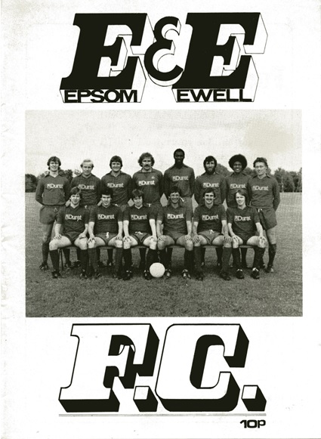
36 years ago today we had a Surrey Senior Cup Semi-Final at Gander Green Lane against the “old enemy” Sutton United. Sutton were chasing a Wembley appearance which would they would achieve in the F.A. Trophy after a two legged victory over Bangor City, while we were chasing promotion. However, by this stage it always looked as though we were just going to miss out and so this match was the main target for us. By the end of the match we were celebrating a goalless draw, which back on those pre-penalty shootout days earned us a replay, one that we would win a few weeks later with the eventual reward of the Surrey Senior Cup for the only time in our history. Sutton lost to Bishops Stortford in the Wembley showpiece and it is worth noting that in four matches against those two teams, our boys remained unbeaten in all of them! (see replay programme pictured)

30 years ago today we suffered our heaviest ever Semi-Final defeat when Sutton United had their revenge with a 5-0 drubbing at Gander Green Lane, again in the Surrey Senior Cup. We were fighting a losing battle against relegation in the Isthmian League Division One, our second in a row, and we were never really in this match, being four nil down by the break!

25 years ago today our in form striker Andy Webster netted a hat trick in a 3-1 Isthmian League win at Cove. It was his 23rd of what would become 26 for the season and his fourth hat trick for the club in just over three months but it was also his last for the club. His career would be a short one as after picking up a persistent ankle injury he would miss the whole of the following season, never playing for us or anyone else again to my knowledge.

8 years ago today we visited Hartley Wintney and missed a great chance in the first minute. What we didn’t realise was that this would be about the only opportunity in the entire match which finished goalless. We had beaten them 5-0 at home earlier in the season and Hartley were relegated. How times have changed!

2 years ago today we defeated Badshot Lea 3-0 at High Road. It was a memorable day for me personally as I got the opportunity to be part of the team, following the whole pre-match ritual and sitting on the bench for the game, learning quickly not to stand up too suddenly in a dug out! More importantly Kyle Hough scored a hat trick to end a bizarre club sequence with our previous nine hat tricks all scored away from home. This was our first at home since Dale Marvell scored three against North Greenford United at Merland Rise in January 2009 and it was also Kyle’s one and only hat trick at home for the club as I write.

Centre page for results

Centre page for results


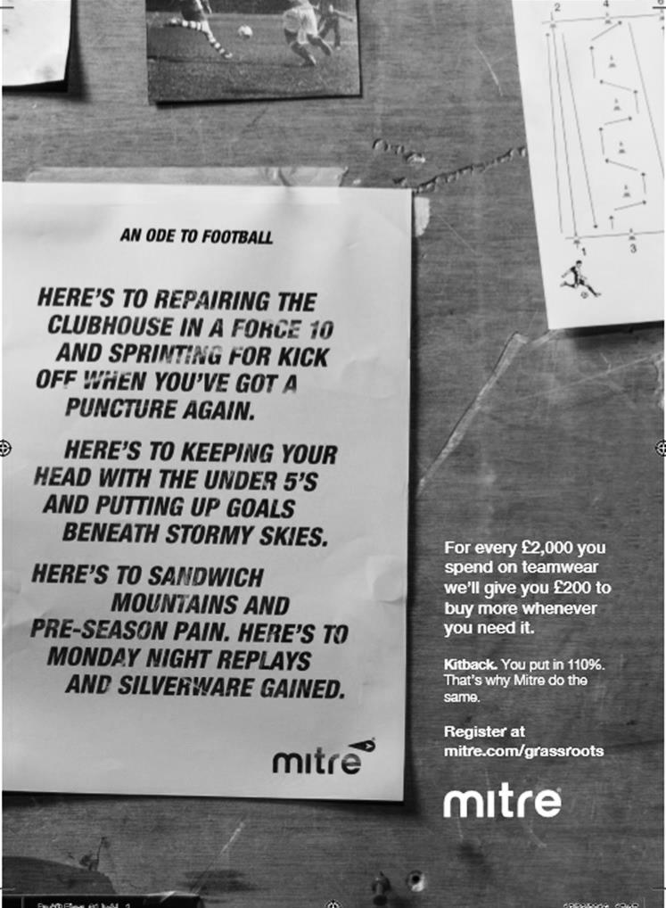

My Club Betting

We can now announce that Epsom & Ewell F.C.
now have our own betting site!

If you like to have a bet, this is most definitely for you.

In conjunction with MyClubBetting.com you can now access all the regular markets that you might do regularly with just a click on our website.

But why would you do this? Many of you already might have apps that you currently use.

The main reason is that you would benefit the club by doing so, but at the same time would not lose out yourselves. Their odds are at least comparable and in many cases better than the other bookmakers out there and by registering with us, the club would make 20% of any cumulative losses and with enough usage, we would qualify for other fairly substantial club benefits.

If you win the bet that you place, that is fantastic news, but whichever company you use currently would keep 100% of any losses. This way our club can receive a nice lump sum in the event that you are unlucky.

For example. If we have 20 people signed up and they lost £25 over the month each, our club would receive £100 back out of the £500 lost.

So just visit: https://eefc.myclubbetting.co.uk/ and join the club, or just visit the link on our main website!

Match and Ball Sponsorships – 2016/17
Opponent | Date | Match Sponsor | Ball Sponsor
Gravesham Borough | 07/08/16 | Club President - Stella Lamont
Gravesham Borough | 07/08/16 | Relocation Committee Member - Mike Lovett
CB Hounslow United | 16/08/16 | EEFC Management Committee
Abbey Rangers | 23/08/16 | Steve & Geoff Dyke
Horley Town (11.30am) | 29/08/16 | In Memory of Chris Henry
Abbey Rangers (LC) | 06/09/16 | Paul Merritt
Camberley Town | 10/09/16 | Building Shop Ltd
Knaphill | 24/09/16 | EEFC Holding Company Director – Pete Lumm
Bridon Ropes (FAV) | 22/10/16 | George and Joseph Saunders
Sutton Common Rovers | 08/11/15 | Alex McKay Senior
Abbey Rangers (FAV) | 13/11/16 | EEFC Holding Company Director – Dave Ellins
Windsor | 15/11/16 | In Memory of Wally Dyke
Bedfont Sports | 19/11/16 | John Bonner
AFC Hayes | 26/11/16 | Jack Jarman
Chipstead (SSC / DWT) | 06/12/16 | Trevor Stotten
Hanworth Villa | 13/12/16 | Roger and Carol Farrell
Chertsey Town | 17/12/16
Raynes Park Vale (11.30am) | 27/12/16 | In memory of Dave and Liz Marshall
Spelthorne Sports | 07/01/17 | Building Shop Ltd
Guildford City (SSC) | 10/01/17 | Super Six Winner – Rita Christian
Guildford City | 17/01/17
Badshot Lea | 04/02/17
Westfield | 18/02/17 | Tony Coome
Walton & Hersham | 04/03/17 | Super Six Winner – Rita Christian
Bedfont & Feltham | 07/03/17 | Programme Editor - Richard Lambert
Hartley Wintney | 18/03/17
Windsor (LC SF) | 21/03/17 | In memory of Bob Bexley
Farnham Town | 25/03/17 | In memory of Jean Bexley
Colliers Wood United (1pm) | 14/04/17
North Greenford United | 22/04/17 | Club President - Stella Lamont
For League, League Cup and Surrey Senior Cup Matches:
Match sponsorship - £40.00 Match ball sponsorship - £25.00. Combined £55.00.
For F.A. Cup and F.A. Vase matches:
Match sponsorship - £50.00 Match ball sponsorship - £30.00. Combined £65.00.

Sponsorship includes: (x2 for match, x3 for match and ball)

Admission, programmes, hospitality and advertising and mascot for the day (if required).

If you are interested, just speak to a Committee Member, or drop me an email at: richard.c.lambert@gmail.com


We also thank our Sponsors INTERCEM and G4 Group

Player Sponsorship
Here is the current list for the 2016/17 season showing all of our players and Management that are available for sponsorship.

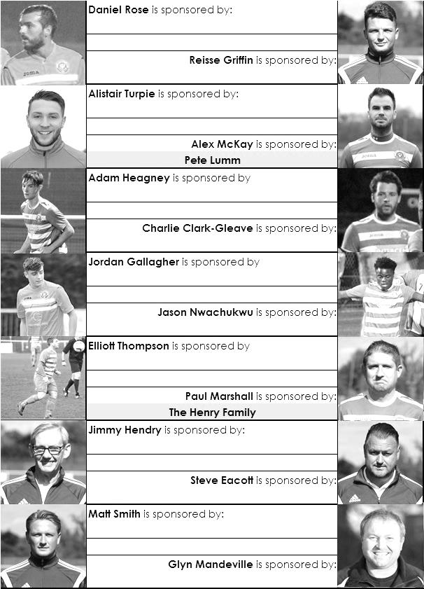

Sponsorship costs just £40 and it is easy to do. Just select a player who has not been previously sponsored and let a Committee Member know that you would like to sponsor them. Beware though. Until we have received the money it is possible for someone to jump in front of you, so don’t delay, sponsor today!
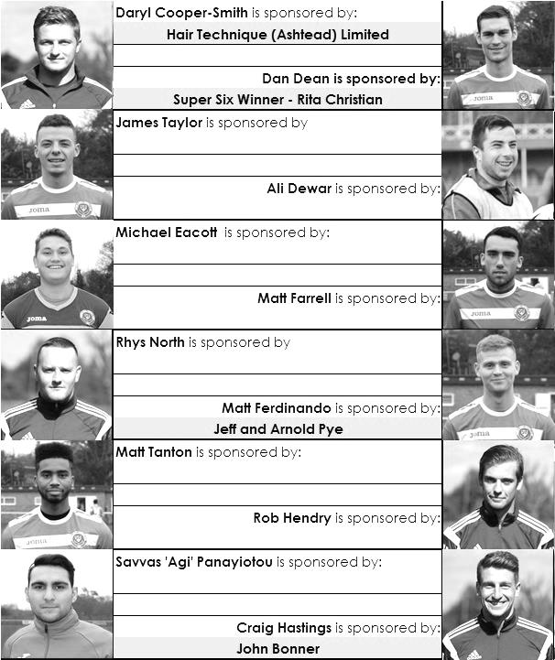

Cherry Red Records Combined Counties League
Premier Division FORM Table – Last 10 Matches
Here is the current state of play based on every club’s last ten League matches. If we keep doing well, the table stays in the programme! Interesting to note that the top five in the League are the top five in this table!

inc Saturday 18th March | P | W | D | L | F | A | Pts | GD
Hartley Wintney | 10 | 9 | 1 | 0 | 35 | 9 | 28 | +26
Epsom & Ewell | 10 | 7 | 2 | 1 | 22 | 9 | 23 | +13
Walton & Hersham | 10 | 7 | 2 | 1 | 20 | 8 | 23 | +12
Hanworth Villa | 10 | 6 | 3 | 1 | 18 | 8 | 21 | +10
Westfield | 10 | 6 | 2 | 2 | 23 | 13 | 20 | +10
Sutton Common Rovers | 10 | 6 | 0 | 4 | 15 | 8 | 18 | +7
Chertsey Town | 10 | 6 | 0 | 4 | 16 | 19 | 18 | -3
Abbey Rangers | 10 | 4 | 5 | 1 | 15 | 11 | 17 | +4
Spelthorne Sports | 10 | 4 | 4 | 2 | 20 | 13 | 16 | +7
North Greenford United | 10 | 5 | 1 | 4 | 17 | 15 | 16 | +2
Farnham Town | 10 | 4 | 2 | 4 | 16 | 17 | 14 | -1
Camberley Town | 10 | 4 | 2 | 4 | 17 | 21 | 14 | -4
Windsor | 10 | 3 | 4 | 3 | 17 | 11 | 13 | +6
Badshot Lea | 10 | 4 | 1 | 5 | 21 | 25 | 13 | -4
Bedfont Sports | 10 | 3 | 2 | 5 | 16 | 19 | 11 | -3
CB Hounslow United | 10 | 3 | 1 | 6 | 9 | 15 | 10 | -6
Knaphill | 10 | 3 | 1 | 6 | 14 | 20 | 10 | -6
AFC Hayes | 10 | 2 | 3 | 5 | 12 | 18 | 9 | -6
Horley Town | 10 | 2 | 1 | 7 | 14 | 20 | 7 | -6
Guildford City | 10 | 2 | 1 | 7 | 12 | 19 | 7 | -7
Raynes Park Vale | 10 | 2 | 1 | 7 | 7 | 19 | 7 | -12
Bedfont & Feltham | 10 | 2 | 1 | 7 | 15 | 32 | 7 | -17
Colliers Wood United | 10 | 1 | 1 | 8 | 13 | 25 | 4 | -12

Surrey Senior Cup
Third Round
Whyteleafe | 2-0 | Egham Town
Badshot Lea | 0-2 | Raynes Park Vale
Epsom & Ewell | 1-2 | Guildford City
Dorking Wanderers | 1-1 8p7 | Sutton Common Rovers
Chertsey Town | 1-0 | Kingstonian
Woking | 2-0 | Leatherhead
Merstham | 5-1 | Walton & Hersham
Tooting & Mitcham United | 0-1 | Knaphill
Quarter Final
Guildford City | 2-1 | Raynes Park Vale
Chertsey Town | 0-3 | Dorking Wanderers
Merstham | 2-1 | Whyteleafe
Woking | 3-1 | Knaphill
Semi Final
Guildford City | 1-2 | Woking
Dorking Wanderers | 21/3 | Merstham

F.A. Vase
Fifth Round – 28th / 29th January
Cleethorpes Town | 3-2 | Atherton Collieries
Southall | 4-2 | Exmouth Town
Bromsgrove Sporting | 2-1 | Bristol Manor Farm
Crowborough Athletic | 3-6 | Coleshill Town
Hinckley AFC | 3-4+ | Buckland Athletic
Newport Pagnell Town | 3-2+ | Sunderland RCA
Ely City | 0-3 | Sporting Khalsa
Team Solent | 2-5 | South Shields
Quarter - Final – 18th February
South Shields | 6-1 | Newport Pagnell Town
Southall | 2-5 | Cleethorpes Town
Bromsgrove Sporting | 2-0 | Buckland Athletic
Coleshill Town | 2-0 | Sporting Khalsa
Semi - Finals - two legs – 11th & 18th March
Coleshill Town | 1-2 | South Shields
South Shields | 4-0 | Coleshill Town
Bromsgrove Sporting | 1-1 | Cleethorpes Town
Cleethorpes Town | 1-0 | Bromsgrove Sporting

Semi-Finals

Following our win at Walton & Hersham in January, we are now into the Semi-Finals of the Combined Counties League Cup.

If I exclude minor competitions like the Southern Combination Cup and Hospital Charity Cups, where there were often not many teams competing, this will be our 34th Semi-Final, not a bad record really for 93 seasons of Senior status existence.

The first question some of you might ask is what is our record in those Semi-Finals? We won 16, drew 8 and lost 9 of the previous 33. Of the eight draws, one was an F.A. Vase Second leg against Stamford, but the other seven required replays, and of those we won three and lost four. Five went to extra time.

So our success record in getting through, including the Stamford draw is 20/33 or 57.58%. This is all the more impressive when you consider how few of the matches we have played at home.

Of those matches, we played 10 at home (plus three replays), yet we played 19 away from home (plus two replays) and four were held at neutral venues (plus two replays). We are finally to get a home tie tonight and it was most definitely due, as the last one we had was back in 1989 against Carshalton Athletic in the Surrey Senior Cup!

It also means that all 13 of our previous home semi-finals (or replays) were played at West Street. In fact we’ve only reached three since we left our old ground, an Associate Members Trophy Semi-Final at Wealdstone that we won 1-0 at their own temporary ground at Edgware F.C. in 1998, a Surrey Senior Cup Semi-Final at Ashford Town (Middx) in 2009 where we were defeated 4-1 and our 1-0 win at Champions Egham Town in the League Cup on our way to winning the cup in 2013.

Our first ever Semi-Final was a Surrey Senior League Charity Cup match at home to Farnham United Breweries in 1927, and although it was named the League Charity Cup back then, it was effectively the same competition we ended up winning in 2013.

We also have a Semi-Final win to our credit against tonight’s opponents, when a Wayne Lewis penalty enabled us to reach the Athenian League Division Two Cup Final after extra time in March 1968.

Our biggest win in a Semi-Final came on 16th February 1952 when Maidenhead United were defeated 8-1 in the Corinthian League Memorial Shield, which was the equivalent of its League Cup.

Our heaviest defeat in a Semi-Final came on 21st March 1987 when we were defeated 5-0 at Sutton United in the Surrey Senior Cup, which co-incidentally was 30 years ago tonight, but in fairness there were three divisions between us at the time!

Here is a list of all our major Semi-Finals.

Epsom & Ewell F.C. Major Semi-Finals
Date | Day | Competition |  | Opponents |  | Scorers
26/02/27 | Sat | Surrey Senior League Charity Cup | H | Farnham United Breweries | 5-2 | Marlow (2), Parr (2), Watts
06/04/29 | Sat | Surrey Senior Cup | N | Wimbledon | 4-1 | Earl (2), Watts, Behn
05/03/32 | Sat | Surrey Charity Shield | A | Nunhead | 2-2 | Payton, Mackesy
13/04/32 | Wed | Surrey Charity Shield rep | H | Nunhead | 0-2
14/01/33 | Sat | Surrey Charity Shield | A | Sutton United | 3-2 | Marlow (2), Rance
27/01/34 | Sat | Surrey Charity Shield | A | Sutton United | 1-3 | Jones
29/04/35 | Mon | London League Cup | A | Streatham Town | 0-1
14/03/36 | Sat | Surrey Charity Shield | H | Redhill | 0-2
05/03/38 | Sat | Surrey Senior Cup | N | Dulwich Hamlet | 2-2 | Rochester, Bruce
23/04/38 | Sat | Surrey Senior Cup rep | N | Dulwich Hamlet | 2-3+ | Jones, Pullen
10/12/38 | Sat | London League Cup | H | Grays Athletic | 5-1 | Stenning (3),  Jones, Curtis
16/02/52 | Sat | Corinthian Memorial Shield | H | Maidenhead United | 8-1 | Goddard (5),  Honey (2), Musto
28/03/53 | Sat | Surrey Senior Shield | A | Woking | 1-3 | Crane
06/03/54 | Sat | Surrey Senior Cup | N | Dulwich Hamlet | 1-1 | Dymott
13/03/54 | Sat | Surrey Senior Cup rep | N | Dulwich Hamlet | 3-2+ | Hurst, Wiles, Avis
26/03/55 | Sat | Surrey Senior Shield | H | Camberley Town | 3-1 | Musto (2), Nuth
09/03/57 | Sat | Surrey Senior Cup | N | Wimbledon | 1-2 | Bangs
30/03/57 | Sat | Corinthian Memorial Shield | A | Chesham United | 1-0 | Bangs
08/03/58 | Sat | Corinthian Memorial Shield | A | Yiewsley | 1-5 | Harris
16/04/60 | Sat | Corinthian Memorial Shield | H | Letchworth | 5-0 | Hawkins (2), Dearlove (2), MacDonald
09/03/68 | Sat | Athenian League Cup | A | Windsor & Eton | 3-2+ | Lewis (pen), Kelly, Eales
09/03/74 | Sat | Surrey Senior League Charity Cup | H | Malden Town | 3-3+ | Wales, Jones, Tuite
26/03/74 | Tue | Surrey Senior League Charity Cup replay | A | Malden Town | 1-3 | Tuite
20/04/74 | Sat | Surrey Senior League Cup | A | Wandsworth | 2-1+ | Tuite, Rose
22/03/75 | Sat | FA Vase first leg | H | Stamford | 2-1 | Lee, Walker
29/03/75 | Sat | FA Vase second leg | A | Stamford | 0-0
12/04/75 | Sat | Surrey Senior League Cup | A | Horley Town | 3-0 | Ritman (2), Tuite
28/04/75 | Mon | Surrey Senior League Charity Cup | A | Merstham | 3-1 | Ritman (2), Tuite
25/04/77 | Mon | Athenian League Cup | A | Farnborough Town | 2-0 | Tuite, Weller
21/03/81 | Sat | Surrey Senior Cup | A | Sutton United | 0-0
14/04/81 | Tue | Surrey Senior Cup rep | H | Sutton United | 3-2 | Hanks (2), Tuite
27/03/82 | Sat | Surrey Senior Cup | H | Croydon | 0-4
26/03/84 | Mon | Surrey Senior Cup | A | Croydon | 2-2 | Morton (2)
12/04/84 | Thur | Surrey Senior Cup rep | H | Croydon | 3-1 | Hill (3)
21/03/87 | Sat | Surrey Senior Cup | A | Sutton United | 0-5
21/02/89 | Tue | Surrey Senior Cup | H | Carshalton Athletic | 2-2 | Hadingham, Perkins
28/02/89 | Tue | Surrey Senior Cup rep | A | Carshalton Athletic | 0-3
17/03/98 | Tue | Associate Members Trophy | A | Wealdstone | 1-0 | Rawlinson
26/03/09 | Thur | Surrey Senior Cup | A | Ashford Town (Mx) | 1-4 | Burns
16/04/13 | Tue | Combined Counties League Cup | A | Egham Town | 1-0 | Jarman

Combined Counties League Premier Division
Opponents All-time Records
incl Saturday 18th  February | P | W | D | L | F | A | PPG | GD | Best  Win | Worst  Loss
Bedfont & Feltham | 2 | 2 | 0 | 0 | 13 | 3 | 3.00 | +10 | 9-2 | X
Spelthorne Sports* | 7 | 5 | 2 | 0 | 15 | 6 | 2.43 | +10 | 6-2 | X
Sutton Common Rovers | 12 | 9 | 2 | 1 | 30 | 14 | 2.42 | +16 | 4-0 | 1-4
Abbey Rangers | 4 | 3 | 0 | 1 | 11 | 4 | 2.25 | +7 | 7-1 | 2-3
Horley Town | 29 | 20 | 5 | 4 | 65 | 30 | 2.24 | +35 | 6-0 | 1-3
Bedfont Sports | 11 | 7 | 2 | 2 | 21 | 12 | 2.09 | +9 | 5-1 | 0-4
Colliers Wood United | 22 | 14 | 2 | 6 | 45 | 33 | 2.00 | +12 | 4-0 | 0-5
Westfield | 20 | 12 | 3 | 5 | 42 | 32 | 1.95 | +10 | 6-1 | 0-4
Guildford City | 18 | 11 | 1 | 6 | 35 | 22 | 1.89 | +13 | 5-1 | 1-5
Farnham Town | 14 | 8 | 2 | 4 | 25 | 23 | 1.86 | +2 | 3-1 | 1-4
Knaphill | 7 | 4 | 1 | 2 | 15 | 8 | 1.86 | +7 | 4-0 | 1-2
Badshot Lea | 19 | 9 | 3 | 7 | 39 | 36 | 1.74 | +3 | 4-1 | 0-4
Hanworth Villa | 17 | 8 | 4 | 5 | 38 | 27 | 1.65 | +11 | 5-0 | 1-4
Walton & Hersham | 52 | 25 | 11 | 16 | 105 | 99 | 1.65 | +6 | 8-0 | 1-9
Raynes Park Vale | 28 | 13 | 7 | 8 | 59 | 38 | 1.64 | +21 | 6-1 | 0-2
Camberley Town* | 89 | 38 | 22 | 28 | 158 | 123 | 1.52 | +35 | 9-1 | 0-4
Windsor | 49 | 19 | 12 | 18 | 90 | 90 | 1.41 | 0 | 4-0 | 0-6
Chertsey Town | 49 | 19 | 5 | 25 | 75 | 87 | 1.27 | -12 | 3-0 | 0-7
Hartley Wintney | 12 | 4 | 3 | 5 | 26 | 21 | 1.25 | +5 | 5-0 | 2-4
North Greenford United | 11 | 3 | 2 | 6 | 15 | 20 | 1.00 | -5 | 3-0 | 1-4
CB Hounslow United | 3 | 1 | 0 | 2 | 4 | 7 | 1.00 | -3 | 2-0 | 1-5
AFC Hayes | 10 | 2 | 3 | 5 | 18 | 18 | 0.90 | +1 | 7-0 | 0-3
* includes one abandoned match v Camberley and one loss on penalties v Spelthorne

Salts Super Six Predictor
The Salts Super Six Predictor is live again for today’s match and the tickets are on sale at today’s game to the left of the gate. The matches are to be played on Saturday.

The jackpot was claimed twice recently but it is already up to £237 so it may not be long before it is getting very large again!

The competition is easy to play! To win, you simply need to predict the results of six matches correctly from the three options, fill in the form and make sure it is back with our seller before the deadline on the ticket. The latest fixtures are shown below.

If you are a club regular, you just need to place your name on the sheet, although if you aren’t, then we’ll need a contact number from you too. We will announce any winners on the website within three working days, so don’t worry, we won’t miss you!

Please note that if there is more than one winner, the prize pot would be shared between the winners. All you need to do now is have a go, as many times as you like!

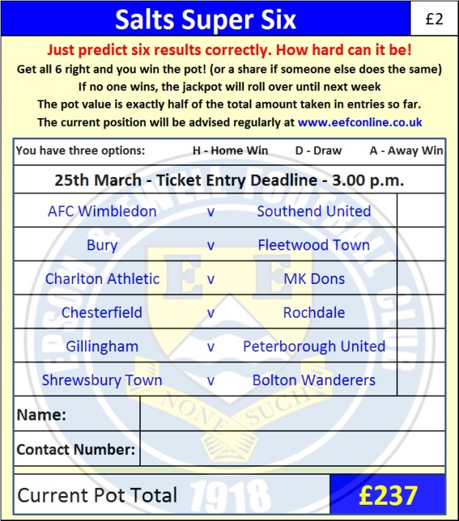

Good luck!

Combined Counties League Cup – Semi-Final
Tuesday, 21st March 2017 - Kick-off 7.45 p.m.

Epsom and Ewell  (Royal Blue & White hoops) | V |  | Windsor  (Green/Red, Green, Green)
Squad | NUMBERS |  | Squad
Michael Eacott |  |  | Dean Aldred
Adam Heagney |  |  | Bradley Birchmore
Matt Tanton |  |  | Denzel Bonilla-Hurtado
James Taylor |  |  | Gus Bowles
© Dan Dean |  |  | Luke Brooks-Smith
Savvas ‘Agi’ Panayiotou |  |  | Riccardo Cannon
Jordan Gallagher |  |  | Haydon Clack
Matt Farrell |  |  | Jamie Di Guiseppe
Rob Hendry |  |  | Barry Dunbar
Matt Ferdinando |  |  | Emmanoyil Goganos
Reisse Griffin |  |  | George Gould
Jason Nwachukwu |  |  | Andrew Ingram
Craig Hastings |  |  | Ellis Jones-Aryeh
Daryl Cooper-Smith |  |  | Keiran Knight
Alex McKay |  |  | Usman Lalustani
Ali Dewar |  |  | Rob Lazarczuk
Alistair Turpie |  |  | Bradley Pearce
Matt Smith |  |  | Henry Poole
Daniel Rose |  |  | Hugo Sobte
Glyn Mandeville | MANAGER |  | Mick Woodham
Matt Smith | ASSISTANT |  | Ashley Smith
Steve Eacott / Alex McKay/  Jimmy Hendry | COACHES / PHYSIO |  | Simone Connor
REFEREE: A.Bennett
ASSISTANTS: P.Maskell, K.Corrick
Today’s match and Match Ball are kindly sponsored
in memory of Bob Bexley

OUR NEXT VISITORS TO HIGH ROAD
Farnham Town
Combined Counties League – Premier Division
Saturday 25th March 2017 – 3.00 p.m.

